Practical No.2
Title: Constraints and TCL
1)Apply PRIMARY KEY,FOREIGN KEY,UNIQUE,CHECK,DEFAULT and NOT NULL constraints while creating the table
Example:
CREATE TABLE Student (
Student_ID INTEGER PRIMARY KEY, Student_Name VARCHAR2(50) NOT NULL,Nick_Name VARCHAR(20),Gender CHAR(1) CHECK (Gender IN ('M', 'F')), Age NUMBER(3), Marks FLOAT,Percentage NUMBER(5,2), Mobile_No NUMBER(10) UNIQUE,Email VARCHAR2(100) UNIQUE, Admission_Date DATE,Admission_Time TIMESTAMP, Is_Active CHAR(1) DEFAULT 'Y',Address CLOB,Photo BLOB );
Output:
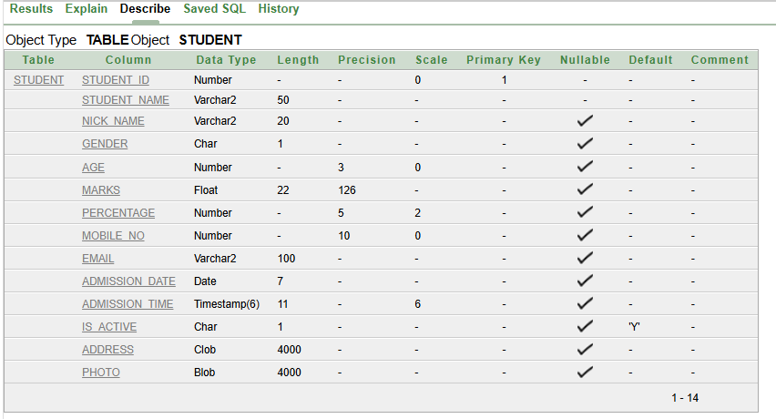
create table class(class_id int primary key,class_name varchar(20),classroom_no int,stud_id int,foreign key(stud_id)references student(Student_ID));
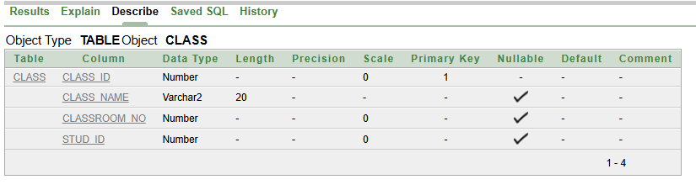

2)Demonstrate COMMIT,ROLLBACK,and SAVEPOINT using suitable examples
- COMMIT-
Syntax:
COMMIT
Example:
INTO Student VALUES (101, 'Rahul Sharma', 'Rahul', 'M', 20, 450.5, 90.10, 9876543210, 'rahul@gmail.com', DATE '2026-06-15', TIMESTAMP '2026-06-15 10:30:00', 'Y', 'Pune, Maharashtra', NULL)
Commit;

Output:
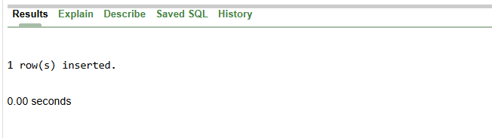

- ROLLBACK
Syntax:
ROLLBACK
Example:

INSERT INTO Student (
Student_ID, Student_Name, Nick_Name, Gender, Age,
Marks, Percentage, Mobile_No, Email,
Admission_Date, Admission_Time, Is_Active, Address, Photo
)
VALUES (
101, 'Sneha Kulkarni', 'Snehu', 'F', 19,
420, 84.00, 9876501234, 'sneha@gmail.com',
TO_DATE('10-07-2026', 'DD-MM-YYYY'),
TIMESTAMP '2026-07-10 09:30:00',
'Y', 'Mumbai, Maharashtra', NULL
);
ROLLBACK;
Output:
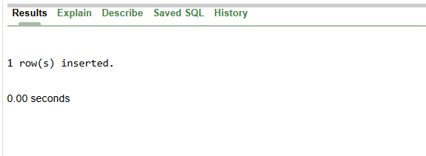

- SAVEPOINT
Syntax:
SAVEPOINT savepoint_name;
Example:
INSERT INTO Student (
Student_ID, Student_Name, Nick_Name, Gender, Age,
Marks, Percentage, Mobile_No, Email,
Admission_Date, Admission_Time, Is_Active, Address, Photo
)
VALUES (
102, 'Karan Patil', 'Karu', 'M', 21,
480, 96.00, 9876501235, 'karan123@gmail.com',
TO_DATE('15-07-2026', 'DD-MM-YYYY'),
TIMESTAMP '2026-07-15 11:30:00',
'Y', 'Pune, Maharashtra', NULL
);
SAVEPOINT s1;
Output:
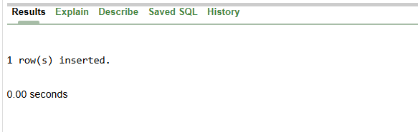

3)Create Department and employee table with appropriate constraints,insert valid and invalid records and observe the behaviour of integrity content
Departmennt table:
CREATE TABLE departmennt (
Dept_ID NUMBER(3) PRIMARY KEY,
Dept_Name VARCHAR2(30) NOT NULL UNIQUE,
Location VARCHAR2(30) DEFAULT 'Mumbai');
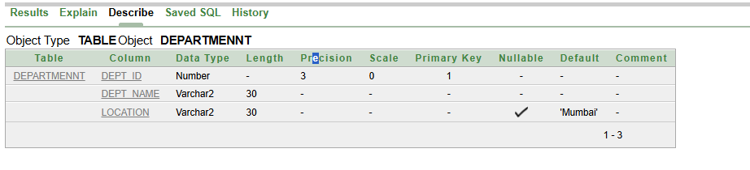

Employe table:
CREATE TABLE Employe (
Emp_ID NUMBER(4) PRIMARY KEY,
Emp_Name VARCHAR2(50) NOT NULL,
Email VARCHAR2(100) UNIQUE,
Salary NUMBER(8,2) CHECK (Salary > 0),
Gender CHAR(1) CHECK (Gender IN ('M', 'F')),
Dept_ID NUMBER(3),
FOREIGN KEY (Dept_ID)
REFERENCES Departmennt(Dept_ID) );
Output:
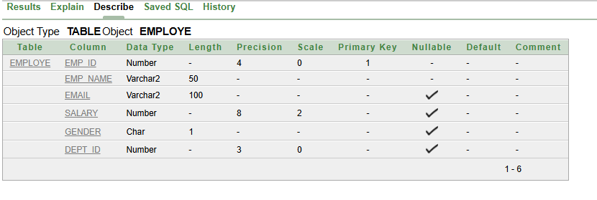

Valid Records:
In Departmennt table:
INSERT ALL
INTO Departmennt VALUES (10, 'HR', 'Mumbai')
INTO Departmennt VALUES (20, 'IT', 'Pune')
INTO Departmennt VALUES (30, 'Finance', DEFAULT)
select * from dual;
select* from departmennt
Output:
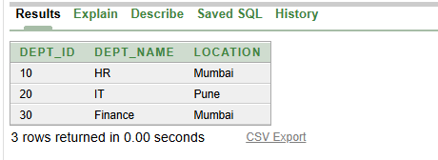

In employe table:
INSERT ALL
INTO Employe VALUES (101, 'Amit Sharma', 'amit@gmail.com',35000, 'M', 10)
INTO Employe VALUES (102, 'Priya Patil', 'priya@gmail.com',45000, 'F', 20)
INTO Employe VALUES (103, 'Rohan Desai', 'rohan@gmail.com',40000, 'M', 30)
select * from dual;
select * from Employe;
Output:
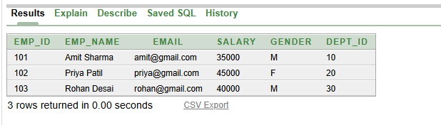
Invalid Records:
INSERT ALL
INTO Employe VALUES (101, 'Amit Sharma', 'amit@gmail.com',35000, 'M', 10)
INTO Employe VALUES (102, 'Priya Patil', 'priya@gmail.com',45000, 'F', 20)
INTO Employeee VALUES (103, 'Rohan Desai', 'rohan@gmail.com',40000, 'M', 30)
select * from dual;
Output:
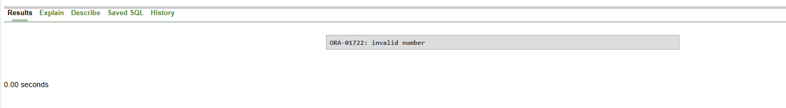

Observations the behaviour of integrity content:
1. Primary Key Constraint: It does not allow duplicate or NULL values in the primary key column.
2. NOT NULL Constraint: It does not allow NULL values in the specified column.
3. UNIQUE Constraint: It does not allow duplicate values in the specified column.
4. CHECK Constraint: It allows only those values that satisfy the specified condition.
5. Foreign Key Constraint: It does not allow a value in the foreign key column that does not exist in the referenced parent table.
6. DEFAULT Constraint: It automatically inserts the default value when no value is specified for that column.

